Disaster and Emergency Preparedness Manual
Tinker Swiss Cottage Museum and Gardens
Approved and Adopted by the TSCMG Board March 2013
Revision Date: March 2018

Part 1: Preparedness
- Introduction
  - Introduction
  - Interpretation, Revision and Approval of the Manual
  - Important Reminders
  - A Special Note on Volunteers and Emergencies
  - Emergency Phone Numbers
  - Miscellaneous Information
  - Interaction with the Media
  - Insurance Information
- Authority and Delegation
- Disaster Response
  - Explanation of Levels
  - Level 1
    - Disgruntled Visitor
    - Small Plumbing Problem
  - Level II
    - Animal Bites
    - Bodily Waste Disposal
    - Break In
    - Broken Collection Object & Building-Object Problem Report
    - Computers
    - Flood
    - Heating, Ventilation, Air Conditioning
    - Injured Staff Member
    - Injured Visitor
    - Personal Assault
    - Pest Management
    - Utility Failure
  - Level III
    - Bomb Threat
    - Explosion
    - Fire
    - Natural Disaster
    - Problem Patrons
    - Structural Damage/Collapse
- Maps

Part 2: Recovery
- Items to save first
- Recovery Schedule
- Storm Specific Recovery Procedures
- Storage of Misplaced items
- Long Term Responses
- Emergency Assistance Numbers
Part One: Preparedness

      - Introduction
This Disaster and Emergency Preparedness Manual (DEPM) was formulated to provide guidelines for staff and volunteers in response to an emergency. An emergency could take many forms, which is why it is essential that emergency planners examine not only how a disaster can be avoided, but what should be done when one happens. In the event of disaster, this DEPM Manual will help the staff and support person(s) to guarantee that proper care and safety of individuals, objects, and the buildings. If a situation occurs that is not covered within the DEPM, use common sense to react appropriately for the staffing and disaster situation.
It is the responsibility of the Executive Director to introduce the Manual to the museum and certify compliance with the policies by all Museum staff, volunteers and the Board of Trustees.

      - Interpretation, Revision, and Approval of the Manual
The Executive Director, with the Board of Trustees, or its designated committee, reviews, revises and develops any necessary DEPM at least once every five years to ensure that they conform to prevailing standards, ethics, and regulations and that they reflect any change in the Museum’s circumstances since the last review.
Revisions to the TSCMG Collection Policy and Procedure Manual must be approved by the Executive Director and the Board of Trustees.
      - Important Reminders
- Human life and safety are the most important considerations in an emergency. They are more important than the collections and material assets of the institution.
- In the event of an evacuation (this includes fire drills), all staff, visitors, and other on-site workers must evacuate all buildings and meet at the main visitor parking lot located off Kent Street.
- If an emergency occurs in a building where there are visitors present, the person who is at the front desk when the evacuation occurs must be able to account for all visitors.
- If the museum is closed to tours but open for business, the Executive Director will have a staff list in his office.
- The Executive Director will handle all press contacts. Only the Executive Director will/may speak to the press.
- After every disaster, key personnel will meet to debrief and change the DEPM accordingly. These personnel will be identified after the disaster.

      - A Special Note on Volunteers and Emergencies
Our volunteers can provide very important services in the event of emergencies. They are the ones who will be on tour with visitors if there is a fire in the Cottage. They may answer the phone when a bomb threat is called in. They will be present when someone trips on the front steps of the Cottage. In general, they will, in many cases, be the first person on the scene in a problem situation.
It is important that they are made aware of our adopted procedures for handling these situations and what is expected of them. We also need to believe in their ability to cope with situations for which we have prepared them. Their actions could determine the difference between a problem and a disaster.
Here are a few guidelines that should prove helpful to the volunteers in the handling of emergency situations:
- Don’t Panic- The best way to handle any problem is to try and remain calm. A panicked reaction to a problem will only compound it and could create new problems that could have been avoided.
- Seek Assistance- If help is needed, call for it. It is the responsibility of the staff to deal with disaster situations. They have been trained for it, so let them handle these things when they arise.
- Provide Assistance- If asked to do something by the staff member in the course of an emergency, please do your best to comply. The biggest responsibility shared by staff and volunteers is the protection of the general public. Our visitors come first. It is then the staff’s responsibility to see to the protection of the volunteers.
- Spread Order- If you are calm and professional in the face of a problem, our visitors will behave likewise in most cases. Do your job and calmly lead or direct guests away from dangerous areas and they will react in an orderly fashion.
- Common Sense- Protect our visitors and protect yourself. Let the staff and emergency services worry about the rest. It is their job.

      - Emergency Numbers
Fire
Emergency………………………….……….…… 911
Non-Emergency…………………………….……. (815) 987-5645

Police
Emergency 911
Dispatch, non-Emergency (815) 963-7687
Rockford Park District Police (815) 987-5800
Rockford Park District, Non-Emergency (815) 987-8874

Ambulance/Rescue Squad
Emergency 911
St. Anthony’s Hospital (815) 226-2000
Swedish American Hospital (815) 968-4400
Rockford Memorial Hospital (815) 971-5000

Poison Control Center 1-800 942-5969

Animal Control (815) 877-3073

Utilities
HVAC –Barn
Mechanical Inc (815) 297-6100
HVAC- Cottage
Tru-Temp (815) 282-9204
Electrical
ComEd 1-800 334-7661
Gas
Northern Illinois Gas Co (815) 965-2011
Water
City of Rockford (815) 961-3777
JULIE 1-800-892-0123

      - Miscellaneous Information
Security System
The burglar alarm in the Cottage, Barn, and Carriage House are monitored and maintained by Per Mar Security. The alarms are sensitive to motion and sound and the doors and windows are alarmed. When an alarm is tripped and the house is closed, Per Mar Security calls the police and a member of the staff at his/her house. During business hours, Per Mar calls the offices first. The first person Per Mar reaches will then coordinate the response to the problem. The Per Mar Security call list is:
- Steve Litteral, Executive Director
Most full-time staff members have codes to set and disarm the alarm of the Barn, Cottage, and Carriage House. If a position requires the individual to arrive earlier or stay later than everyone else, they will receive a code.
Shut-off Valves
In the event that electrical, gas, or water need to be shut off in one or more of the buildings, the location should be known by all staff.

- Gas Shut-off
Call Northern Illinois Gas Co.
815-965-2011

- Electrical Shut-off
Cottage
- Breaker switches are located on the North wall of the furnace room in the lower level of the Cottage.

Carriage House
- Breaker switches are in the southwest corner of the office.

Barn
- Breaker switches are located on the north wall of the storage closet in the first floor of the Barn (southeast corner of the multi-purpose room).

- Water Shut-off
- If a water line breaks, shut it off at valve
  - The shut off valves for each building are next to the water meters.
Carriage House
  - Behind door to the furnace/coffee room to the left of the water heater. Near floor, left of water meter – white handle. Shuts off water to entire building.
Cottage
  - The meter and valve are in the lower level in the sump pump room (go down the stairs from the kitchen or the west door and go into the first room on your right just after you get off the stairs). The shut-off lever is green.
  - A second shut off valve is above the pump room door. This turns off the water pipe under the conservatory porch.
Barn
  - Water meter is located in the Mechanical room on the first floor (east side of the multipurpose room). The shut-off lever is blue.
  - To shut off the water at each toilet in the Barn, go to the pipe above the toilet on the far left, parallel to the floor. Remove the outermost nut and insert a screwdriver, turning clockwise to turn off water. To turn the water back on, insert the screwdriver and turn counter clockwise (to the left). Replace the nut when finished.

      - Interaction with the Media
During a crisis, it is extremely important that consistent, accurate and timely information be disseminated to the media. All interactions with the media concerning the nature and extent of the disaster, possible damage to the museum’s collections and resumption of normal public access to the museum is to be handled through the Executive Director or their designated spokesperson.
It is important that all other staff, volunteers, and Board Members do not answer any questions from individuals, regardless of who they are.
      - Insurance
The Rockford Park District supplies coverage for the Buildings on the Museum grounds. General liability, personal property, collections, directors and officers, and non-owned automobiles are covered through a policy obtain by the TSCMG.

- Authority and Delegation
Staff Phone Tree
Steve Litteral
Executive Director
Cell (779) 770-4717

Alix Fox
Education Coordinator
Cell (815)509-0308
Ashley Downing
Curator of Collection
Cell (815) 988-9341

- Disaster Response

- Explanation of Levels

Level I – Minor Problems
Small plumbing problems, disgruntled visitor
- Contact the person who can fix the problem. Call someone off-site only as necessary.
- The Executive Director only needs a cursory explanation the next time they are in the office
- Follow up, as necessary, by the appropriate person, not the Executive Director

Level II – Mid-level Problems
Down but repairable equipment, injured staff or visitors, broken collection object, after-hours break-in to building, flood.
- Off-site repair or assistance contacted by on-site staff as appropriate.
- Off-site staff may or may not need to come in; they may need only to be informed.
- The Executive Director is the last to be called to the scene, but should be informed of the incident on the day it happened. If the incident occurs on a weekend, they may or may not need to come on-site.
- The Executive Director, or their designated staff, will contact any appropriate outside sources for follow up (lawyer, insurance, etc.) and write an incident report
- Copies of incident reports can be found in the Carriage House.

Level III – Major Problems
Fire, bomb threat, explosion, vandalism, collapse of structure
- After 911 is called and the building is evacuated (if necessary), the Executive Director and the Board of Trustee President are the first to be called.
- Executive Director, or their designated staff, directs the on-site situation.
- The Executive Director and the Board of Trustee President, directs press contacts and are the only individuals who will/may speak to the press.
- Executive Director leads any follow up and will write an incident report.

- Level I – Disgruntled Visitor, Small Plumbing Problem

- Disgruntled Visitor
- If possible, do not get into a confrontation with a disgruntled visitor in front of others.
- Remain calm. Listen to the person’s complaint.
- If necessary, contact the appropriate staff person to deal with the visitor’s issue.
- If no one is available, take down the visitor’s name and phone number and tell them someone will get back to them as soon as possible.
- If the visitor gets abusive, contact the Rockford Police Department or the Rockford Park Police.

- Small Plumbing Problem
- If a toilet or sink is non-operational, tape up a notice for the visitors so the problem does not get worse.
- Notify the Executive Director, or their designated staff, of the problem.
- If the problem cannot wait, contact Pearson Plumbing and Heating (815) 398-8312

- Level II – Animal Bites, Bodily Waste Disposal, Break- In, Broken Collection Object, Computers, Flood, HVAC, Injured Staff Member, Injured Visitor, Personal Assault, Pest Management, Utility Failure

- Animal Bites
- Domestic Animals:
  - Immediately have the guest wash the wound thoroughly with antiseptic soap and water.
  - Do NOT give any medications, including aspirin.
  - Go to a hospital emergency room or doctor immediately.
  - Complete an incident report. If possible, have the injured person concur with the report. Give a copy of the report to the Executive Director.
  - Call Animal Control who will find the animal’s owner, check vaccinations, etc. The animal should be confined and observed for 10 days.
  - Provide Animal Control with contact information for the victim.
  - Inform the Executive Director. They will contact the insurance company as necessary.
- Wild Animal:
  - Immediately have the guest wash the wound thoroughly with antiseptic soap and water.
  - Do NOT give any medication, including aspirin.
  - Go to a hospital emergency room or doctor immediately.
  - Complete an incident report. If possible, have the injured person concur with the report. Give a copy to the Executive Director.
  - Do NOT attempt to capture a wild animal alive.
  - Call Animal Control or the police for assistance. Animal Control will take away the animal, test it, and treat/destroy as necessary.
- At the Site:
  - Use extreme caution if there is blood in the area, either from the victim or animal. Avoid any contact with blood and/or saliva by wearing gloves.
  - If the animal is destroyed on the property, cordon off the area until it can be disinfected. Spray the ground, shoes, tools, containers, and anything else that came in contact with the ground or animal with a spray solution of household bleach and water.
  - To clean the contaminated area
    - Always wear gloves.
    - Decontaminate the area with a solution of water and undiluted sodium hypochlorite (bleach).
    - Rinse with water as necessary.
    - Thoroughly wipe down any surfaces that have been exposed
  - Solid waste should be sealed in a plastic container and disposed of in the dumpster.
  - Gloves cannot be washed or decontaminated for reuse. Dispose of them along with any used cleaning products.
  - Wash hands with soap and water immediately after removing protective gloves.

- Bodily Waste Disposal
If a visitor has had an “accident” in the house while on a tour:
- Be sure to keep all other members of your tour group away from the area.
- Escort the visitor out of the house and notify someone to come clean the area.
- Do not leave the area until someone has arrived to clean.
- The tours behind you may not know that an accident has occurred.

- Break-Ins
All of the buildings on the Tinker Swiss Cottage Museum campus are tied to external security companies. The alarms are sensitive to motion and sound and the doors are alarmed.
- When an alarm is tripped and the museum is closed, the security company calls the police and the Executive Director at his/her home. During business hours, the on-site staff gets called first, to determine if there is a real problem.
- The Executive Director will meet the police and assess the damage, if any.
- After the incident, the Executive Director will notify all staff of the break-in, and determine the best course of action to fix the problem.

- Broken Collection Object
Collection objects get broken. Every effort should be made to avoid accidents by being vigilant to the movements of visitors and staying clear of museum objects. However, because tours bring visitors into the rooms with minimal ropes, objects are likely to get knocked over.

If an object gets broken when you are around, do not try to conceal it. If the Executive Director, or their designated staff, knows about the broken object, it can probably be repaired and/or protected.

If an object is broken on tour:
- Ask visitors to step away from and not to touch the broken object.
- If it is a weekday, contact the Executive Director, or their designated staff.
- If it is a weekend and the Executive Director, or their designated staff, are not around, contact the staff on-site and tell them where the object was broken and what kind of an object it is.
- The staff member will remove the object from site.
  - If the object is broken, bring a container to collect the pieces.
  - Use white cotton gloves and an acid-free box to gather all the pieces of the broken object. Be careful of any sharp edges.
  - If the object is not in pieces, assess if it can stay on display or should be removed.
  - Write a description of what happened and e-mail it to the Executive Director, or their designated staff
  - The Executive Director, or their designated staff, will contact you the next working day with any questions.

- Computers
- In the event of a computer crash, call Garsha Computers. They will be able to walk you through a repair of the problem or respond in person, depending on the severity of the problem.
- The server is located on the first floor of the Carriage House.

- Flood
- Identify the source of the leak. Stop the flow if possible or divert it to an area where it will do less damage.
- Notify the Executive Director, or call his/her cell phone.
- Turn the electricity to the affected area off. If you cannot do so easily, or are uncomfortable doing so, do not attempt it.
  - Water carries electricity. Do not walk through a flooded area until the electricity is turned off
- If a water line breaks, shut it off at valve
  - The shut off valves for each building are next to the water meters.
Carriage House
  - Behind door to the furnace/coffee room to the left of the water heater. Near floor, left of water meter – white handle. Shuts off water to entire building.
Cottage
  - The meter and valve are in the lower level in the sump pump room (go down the stairs from the kitchen or the west door and go into the first room on your right just after you get off the stairs). The shut-off lever is green.
  - A second shut off valve is above the pump room door. This turns off the water pipe under the conservatory porch.
Barn
  - Water meter is located in the Mechanical room on the first floor (east side of the multipurpose room). The shut-off lever is blue.
  - To shut off the water at each toilet in the Barn, go to the pipe above the toilet on the far left, parallel to the floor. Remove the outermost nut and insert a screwdriver, turning clockwise to turn off water. To turn the water back on, insert the screwdriver and turn counter clockwise (to the left). Replace the nut when finished.

- If flooding is extreme, call 911 and ask for the fire department. They will use sump pumps or emergency pumps to drain flooded areas.
- If possible, move dry items away from the water source. See Part II for Collection Salvage Instructions.
- After the water is cleaned up, use dehumidifiers to dry areas. The humidity controls on the HVAC system can be altered to dry large areas. Contact the Executive Director, or their designated staff to alter the system.

- HVAC
- Notify the Executive Director, or their designated staff, by calling if the heating or air conditioning is not working.
- Try to determine how long the failure is likely to last and inform the visitors and staff.
- Limit opening and closing of doors to retain residual heat or cooling.
- High Heat:
  - Use natural cooling factors: close shades and drapes and turn off lights.
  - Use portable fans to move air. Put fans in doorways to circulate air.
  - Use portable dehumidifiers if the humidity is high.
- Open selected doors or windows, being sure to maintain security.
- Vent the upper levels- heat rises.

- Injured Staff Member
- Notify the Executive Director of the injury immediately.
- Complete an incident report. The original document should be given to the Executive Director.
- If appropriate, the Executive Director will contact Workman’s Compensation Claim Administrator.
- If you need to seek medical help, see a doctor approved by your network.
- When seeking medical attention, be sure to give your name and that of the Tinker Swiss Cottage Museum to the doctor so that s/he can submit the bill to the appropriate claim administrator.

- Injured Visitor
- Call 911. Ask the family or other people in the injured person’s party before dialing. It may be a minor routine incident and may not need an ambulance.
- It is always better to err on the side of caution. Even if it seems like a minor injury, encourage the injured person to go to the hospital in an ambulance.
- Stay with the individual who is sick or injured. Provide privacy, comfort, and limited aid to the injured person.
  - Do not move the individual
  - Do not give any medication, including aspirin.
  - Only certified individuals may perform CPR
- Notify the person’s group leader or teacher if appropriate.
- Notify the Executive Director.
- Complete an incident report. If possible, have the injured person concur with the report and provide them with a copy. Give the original to the Executive Director.

- Personal Assault
- Contact the Executive Director.
- If the incident is in progress, do not attempt to accost or apprehend the individual on your own.
- Call 911 for an ambulance and the police if it is necessary. It is always better to err on the side of caution.
- Provide privacy, comfort, and limited first aid for the victim.
  - Do not give any medication, including aspirin.
- Protect the scene; identify suspects and witnesses and record important details.
- Record the incident report number and police names from the police for future reference.
- Complete an incident report. If possible, have the injured person concur with the report and provide them with a copy. Give the original to the Executive Director.
- The Executive Director will contact the insurance company, if appropriate.

- Pest Management
The Tinker Swiss Cottage Museum has a monthly pest management inspection.

- Rodents
  - Never eat or drink in areas where there are collection objects.
  - In all areas, eliminate waste and debris by disposing of leftover food promptly.
    - Be sure to wrap up trash well to eliminate any odor. Move it to outside garbage as soon as possible.
    - Be sure to clean any dishes and/or silverware you have used. Do not leave dirty dishes out in the open.
    - Be sure to cover all garbage cans after use.
  - Search for and seal off any places where the rodents may have access to the building.
  - Consult with the Executive Director about appropriate methods of treatment and disposal. If necessary, the Executive Director will call a professional exterminator.
  - Locate and dispose of dead rodents. Make sure to wear plastic gloves when handling rodents. Dispose of them in outside garbage bins.
- Insects
  - Check all incoming materials for infestation.
  - Capture a specimen.
  - Label the container with the date and location it was found. Do not crush it, if at all possible.
  - If infestation is suspected, inspect the area immediately to determine the extent. Move all infected materials to an isolated room or bag.
  - Identify the source of infestation and eliminate it.
  - Have infested materials treated by a professional.
  - Thoroughly clean infested area.
  - Check collections material regularly for at least six months after treatment.
- Mold
  - Remove all infected materials immediately to an isolated room. Seal materials temporarily in plastic bags.
  - The Executive Director, or their designated staff, will supervise cleaning of infected areas, including the climate control ductwork and system when possible.
  - The Executive Director, or their designated staff, will supervise cleaning of infected objects. If necessary, s/he will consult a conservator for object treatment.
  - The appropriate staff person will monitor uninfected and treated materials for at least six months for evidence of re-infection.

- Utility Failure
- Check that all emergency lighting and exit lighting have switched to battery power. Batteries will last for approximately one hour.
- The telephone will not work in the event of a power failure.
- Report power outage to the power company.
  - ComEd…………………….1-800-334-7661
- Ask how long they estimate the power will be out.
- Organize a system to monitor the building for fire, security, etc. while the power is out.
- Plan for staff security for when the battery power is exhausted.
- If the buildings will be without power for an extended period of time, additional security will be hired. The Executive Director will contact the security company and make the necessary arrangements.

- Level III- Bomb Threat, Explosion, Fire, Natural Disaster, Problem Patrons, Structural Collapse

- Bomb Threat
Bomb threats are becoming more common in museums as they tackle more controversial topics and as increased information on museums and bomb creating techniques become available. Threats can come into the museum in a variety of ways: in person, through email, over the phone, or by mail. Even if it seems strange or silly, take any bomb threat seriously. It is better to be safe than sorry.

It is the policy of the Tinker Swiss Cottage Museum to immediately evacuate all of its buildings when a threat has been made. Staff and visitors will be allowed back into the buildings only after the police have personally cleared the site.

- Remain calm.
- Acquire as much information about the threat as possible.
  - If the threat comes by phone, be calm and courteous; listen and do not interrupt the caller.
  - If someone is in the office with you, write “Call 911 bomb threat” on a piece of paper. This leaves you free to talk to the caller.
- Inform the Executive Director, She/he will call 911 to contact the police immediately.
- Evacuate the building. All staff and visitors should calmly and quickly leave the building via the closest exit.
- Be sure to check the evacuation route carefully for incendiary devices.
- Proceed to the meeting point in the main visitor parking lot located off from Kent Street.
- Re-enter the building only with the permission of the Police Department.
- After the event, key personnel will meet to debrief and change the Disaster Plan accordingly. These personnel will be identified after the disaster.

Bomb threat Questionnaire
- What time will the bomb explode?
- Where did you place the bomb?
- What is it made of?
- What does the bomb look like?
- What will cause it to explode?
- Where are you calling from?
- What is your name?
- After the call is over, CALL 911.

- Explosion
- Remain calm.
- Avoid using the regular telephones. Use a cell phone to call 911.
- Be prepared for possible further explosions.
  - Take cover under a table or desk.
  - Stay away from windows, mirrors, overhead fixtures, filing cabinets, bookcases, etc.
- Notify other staff and visitors to calmly and quickly evacuate the building.
- Be sure to check the evacuation route carefully for structural safety. Open doors carefully: watch for falling objects.
- Do not move seriously injured persons, unless they are in immediate danger.
- Proceed to meeting point: Main visitor parking lot located off from Kent Street.
- Re-enter the building only with the permission of the Police Department.
- After the event, key personnel will meet to debrief and change the Disaster Plan accordingly. These personnel will be identified after the disaster.

- Fire
The Tinker Swiss Cottage, Barn, and Carriage House are equipped with smoke detectors. The Barn and the Carriage House are also equipped with a sprinkler system. On all the PerMar Security panels there are buttons to notify emergency personnel in the event of a fire.

If you see a fire, do not assume that the alarm system will automatically alert the Fire Department. It is safest to first sound a fire alarm, evacuate the building, and then call 911.

Ways to sound a fire alarm
- Smoke detectors (automatic)
- PerMar Security button
- Call 911

Do nothing to endanger your life and safety or anyone else’s. Do not even attempt to approach a fire that is not already contained.

After calling 911, if you feel the fire is small, you may make the personal choice to use a fire extinguisher. You are under no obligations to do so. Fire extinguishers are located on all three floors of the Tinker Swiss Cottage, Barn, and Carriage House.
- Do not let the fire come between you and an exit.
- Do not fight a fire in a smoke-filled space.

When a fire alarm sounds
- Remain calm.
- Initiate evacuation procedure.
  - All personnel must evacuate when the alarm sounds.
  - If you have a tour or visitors, calmly lead visitors to the main visitor parking lot located off from Kent Street.
  - Always check for heat before opening any doors by touching them near the top. If it is hot, or if smoke is visible, do not open the door. Find another escape route.
  - Keep your group together. Do not stop to gather coats, books, etc. If tour visitors leave your group or go to their car, they will be considered unaccounted for, and a search will have to be conducted.
  - Assist anyone who many need help.
- Call 911 or inform the Fire Department by some other means.
- Check the alarm panel. Every building will have a panel which should flash to indicate which zone the alarm is in.
- When the Fire Department arrives
  - Meet the Fire Department, show them the fire system panel, and inform them of any action taken.
  - Keep visitors and staff from entering any of the buildings.
  - Advise the Fire Department of anyone who needs assistance.
  - Advise the Fire Department of any flammable materials or chemicals.
- Special procedures
  - If arson is suspected, advise a fire or police official of any suspicions and observations.
  - If collections are damaged, inform the Executive Director or their designated staff.
- Re-enter the building only with the permission of the Fire Department
- After the fire
  - The Executive Director will inform the insurance agent.
  - The Executive Director will re-establish fire protection systems, replace any fire extinguishers, and reset the detection system.
- The Executive Director will keep a written record of all activities for future reference. A copy should be given to the Finance Department for the insurance file.
- All staff will hold a debriefing and revise the Disaster Plan accordingly.

- Natural Disaster
If there is no warning of the disaster:
- Advise visitors and staff as soon as possible.
- Immediately seek cover. Lead visitors to appropriate refuge.
  - Tornado
    - Cottage- Furnace Room
    - Barn- Furnace Room
    - Carriage House- Furnace Room
  - Earthquake
    - Seek cover in doorways or under strong furniture
    - Stay near the center of the building, stay away from glass windows, doors, display cabinets, etc.
    - Do not use candles, matches or any other open flame as there may be gas leaks.
- When the storm is over, lead visitors out of the building, being sure to check the safety and structural integrity of any space you pass through.
- Proceed to a safe open space.

If a warning or disaster is declared:
- Follow the forecast on television, radio or the Internet.
- Realistically assess the possibility of the storm impacting this area. Remember: it is better to be safe than sorry.
- The Executive Director will decide on a course of action. Depending on the potential severity of the storm, it could include:
  - Tying down loose items located outside or moving them indoors.
  - Moving furniture away from windows, especially furniture original to the house.
  - Taping X’s, using masking or packing tape, on windows. This should be done only if the wind is predicted to be over 100mph.
  - Boarding windows if extreme winds are expected.
  - Pulling curtains, shutters, and blinds.
  - Putting plastic down on floor under vulnerable windows.
  - Using heavy-gage plastic to cover windows where there are no storm panes.
  - Covering the inside of the windows with plywood.
  - Have everyone turn their computers off and unplug them from the wall.
  - Shut off water valves
- If the storm is likely to occur over night, discuss the possibility of a staff member staying on site overnight or checking the property in the middle of the night. Be sure this person is equipped with a cellular phone.
- After the event, key personnel will meet to debrief and change the Disaster Plan accordingly. These personnel will be identified after the disaster.

- Problem Patrons (Theft, Vandalism, Trespassing)
Occasionally, a visitor to the site will cause a problem. The problem may range from someone being verbally abusive to staff or other visitors, to vandalism or stealing an object.
- A staff member will decide whether or not to call 911.
- Do not attempt to accost or apprehend an individual on your own.
- When the Police arrive, explain the situation.
- Move the rest of the group out of the way or out of the building. If your presence is required with the police, ask another staff member or volunteer to take charge of your group.

If the incident is over:
- A staff member will determine whether or not to call the local police.
- Protect the scene, identify any suspects, identify witnesses, and record any memorable details.
- When/if the police arrive
  - The Executive Director, or their designated staff, will escort them to the incident site
  - The person reporting the incident will be identified for the police.
- Provide the police with detailed descriptions of any missing items and any suspects.
  - If a collection item is missing, they staff will provide the police with estimated value, description and a photograph, if possible.
- Record police report number, police names and identification numbers.
- Re-secure the building when given permission by the police.

Following the incident
- The Executive Director will report the incident to the insurance agent.
- If the incident involved an object loaned to Tinker Swiss Cottage Museum, the original lender will be notified and kept in the loop as the investigation progresses.
- If necessary, a legal advisor will be consulted.
- Check with police for progress.
- After the event, key personnel will meet to debrief and change the Disaster Plan accordingly. These personnel will be identified after the disaster.

- Structural Damage/Collapse
If someone is trapped or injured:
- Volunteers and staff will contact the Executive Director who will call 911.
- Wait with the injured party until help arrives.
- Ask another staff member to lead non-injured visitors and/or staff out of the building. Calmly lead them to the Tinker parking lot.
- Keep the group together. If visitors leave or go to their car, they will be considered unaccounted for and a search will have to be conducted.
If no one is injured in your group:
- Calmly lead visitors out of the building to the Tinker parking lot.
- Inform the Executive Director
After the incident:
- Tape off the damaged area so that no one can enter.
- As soon as possible, contact an architect or engineer to evaluate the situation.
- Under consultation with the architect/engineer:
  - Determine if the area can be safely occupied.
  - Stabilize to prevent further damage.
  - Document damage with photographs prior to any activity.
- Do not allow any materials to be removed from the site until the museum’s staff and/or professionals with historic building experience have evaluated what materials should be salvaged. Some decorative elements may not be salvageable for reuse, but can provide patterns for reconstruction.
- After the building has been declared safe, the curatorial department will supervise the removal of collections and other assets.
- After the event, key personnel will meet to debrief and change the Disaster Plan accordingly. These personnel will be identified after the disaster.

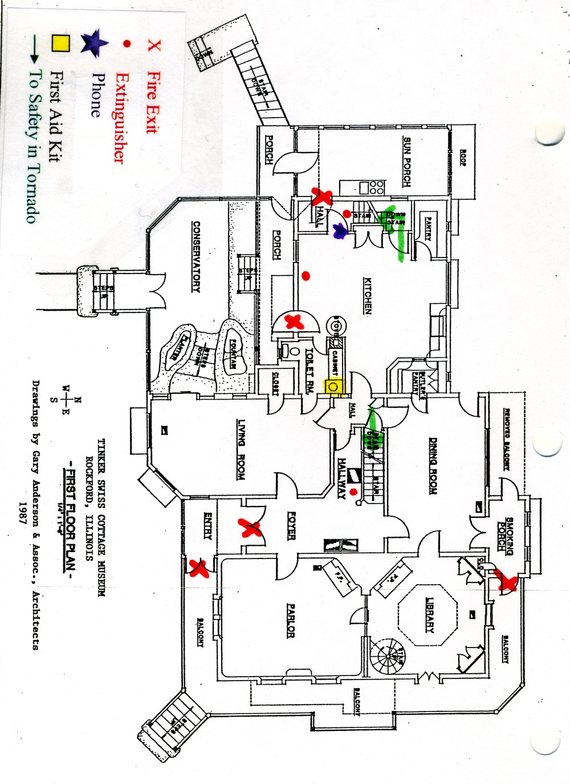
Cottage Floor Plan- 1st Floor

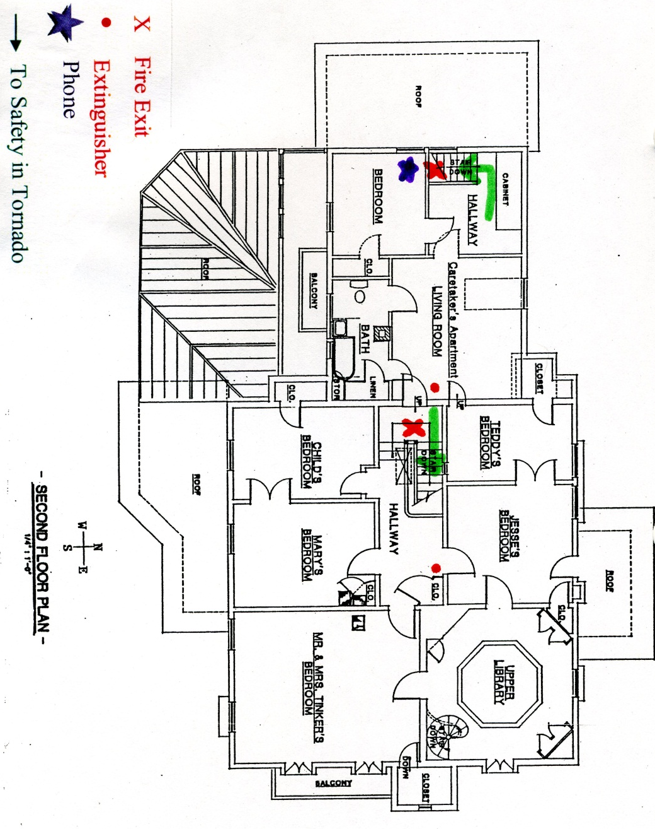

Cottage Floor Plan- 2nd Floor
Cottage Floor Plan- Basement
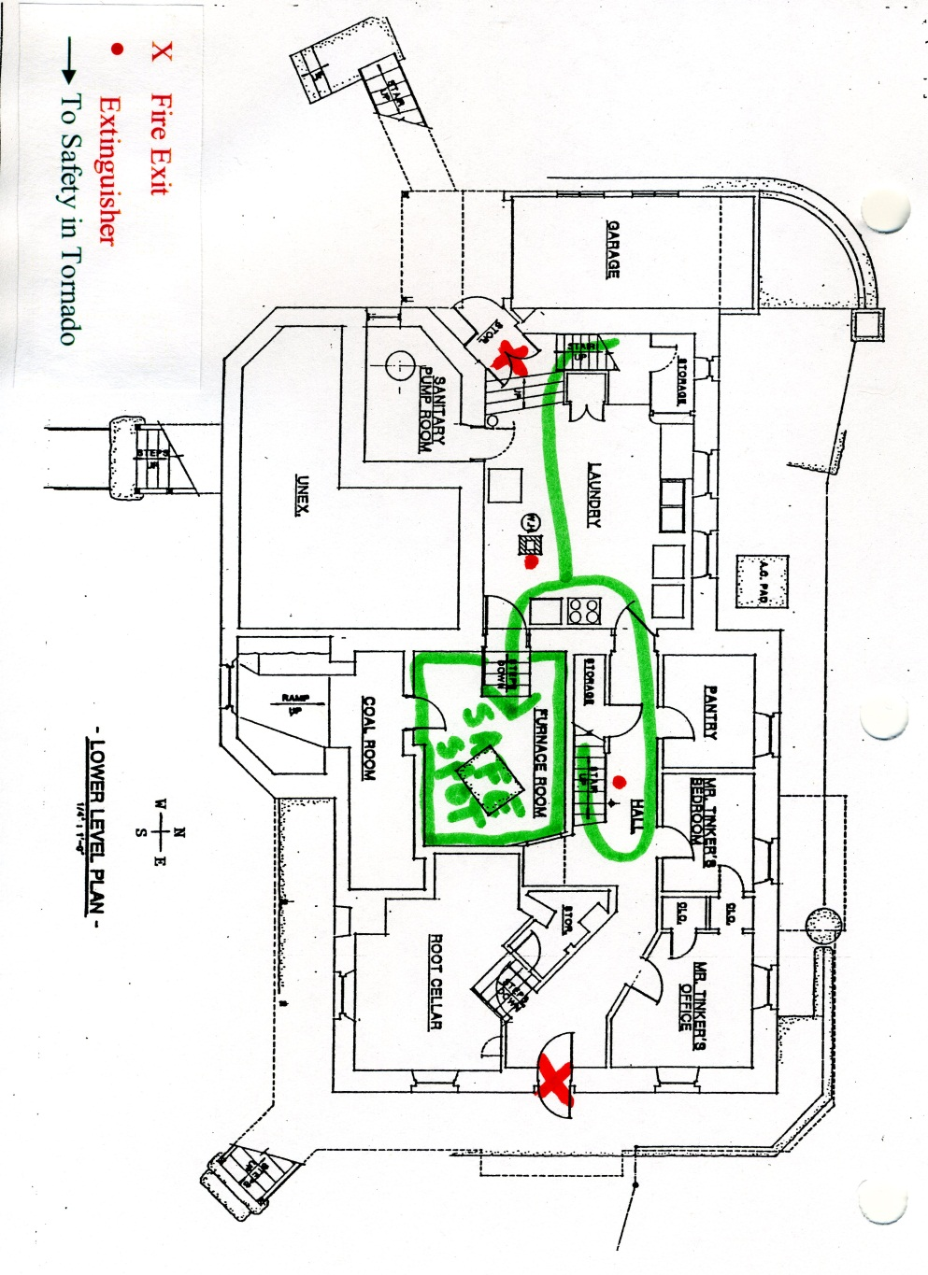
Barn Floor Plans
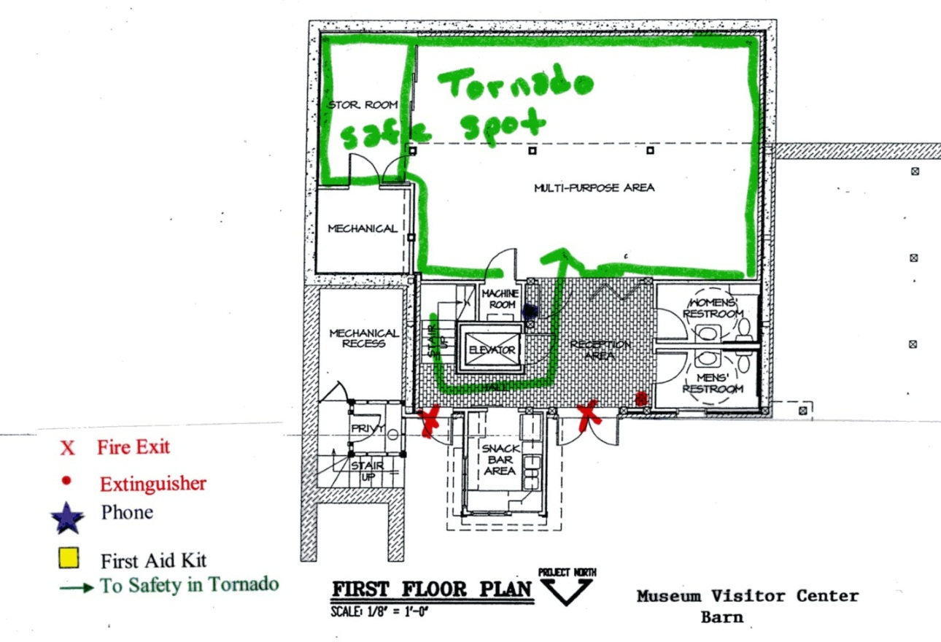

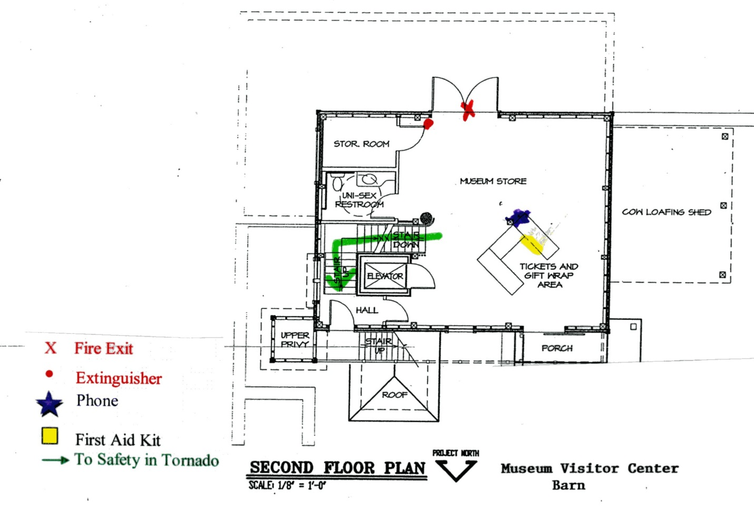
Part Two: Recovery

- Save First List
There are certain items within the TSCMG collection that have been found to be of top priority to preserve. In any type of disaster, these items must be found and examined before any other item. Artifacts are continually updated and location can be found in PastPerfect. The PastPerfect program can be found on all staff computers, is saved to the server, and is saved weekly to an external hard drive that can be found in the storeroom safe. The Save First List has been given to the Curator, a member of the Collection Committee, and the Board of Trustee President.

- Accessories
  - Dolls
    - 95.002-95.014
    - 2006.025
  - 98.030.01-98.030.08- 8 piece English Chintz Pattern Chamber Set 89.171.01-89.171.02- French Bronze Candelabras
  - 89.172- French Bronze Clock
  - 89.173.01-89.0137.02- Bronze Figure 2007.194- Volks head of Lincoln
  - 2012.006-2012.007- Blanc du chine Temple Vases
  - 2012.384- Chinese Bronze Sword and Stafford
  - 98.014- Staffordshire Inkwell
- Books
  - 87.040.01-.07 Birds of America John A. Audubon
  - 87.042.01-.03 Quadrupeds of North America-John A. Audubon
  - 87.046.01-.04National Portrait Gallery
  - 87.047.01-.03- History of the Indian Tribes of N. America
  - 87.570-Family Bible
  - 87.598-Hawaiian Bible
  - 87.599 Magni Gothe Libre book
- Furniture
  - Bedroom sets
    - 89.020-89.023
    - 89.031—89.033
    - 89.042-89.045
    - 89.051-89.055
    - 89.103-89.105
    - 89.127-89.128
  - 89.010- Oak chair
  - 89.034-89.035- Walnut desk
  - 89.036- Walnut bookcases
  - 89.037- Tripod candle stand
  - 89.046.01-89.046.06- Ladder-back chairs
  - 89.049- 4-drawer chest
  - 89.057- Turtle top-marble top table
  - 89.058- Lincoln Rocker
  - 89.059- Empire secretary
  - 89.060.01-89.060.04- Low Gothic Carved Slipper Chairs
  - 89.064- Dish top candle stand
  - 89.072- Piano
  - 89.073.01-89.073.03- Parlor Suite
  - 89.074- Victorian Étagère
  - 89.076- Empire Sofa
  - 89.094- New England Step-down Windsor Rocker
  - 89.116- Federal arm chair
  - 89.117.01-89.117.08 8 captain chairs
  - 89.120- Oak china Cabinet Bow-front chest
- Paintings
  - 89.166-Painting of Mr. Manny
  - 89.170-Painting of Rueben Tinker
  - 89.177-Angel Gabriel painting
  - 89.183-Mary Manny Tinker-oval portrait
  - 89.184-The Sorrowful Virgin Marry
  - 89.188.01-89.191Paintings in pressed wood oval frames
  - 89.198.01 Miniature portraits of Reuben Tinker
  - 89.198.02 Miniature portrait of Mary Throop Wood Tinker
  - 89.209 Charcoal Drawing Robert Tinker
  - 2011.041Audubon Print
  - 2011.057-Primitive Portraits of Milton Dorr by Ammi Phillips
  - 2011.056- Primitive Portrait of Sarah Dorr by Ammi Phillips
  - 2012.651-The Family Record

- Recovery Schedule
Recommended by the National Trust for Historic Preservation, the following schedule can function as a guide for recovery after a serious disaster. It should be emphasized that recovering will not take place overnight. Depending upon the severity of the disaster, it could take many months and much economic support.

      - Immediate to One Year:
        - Stabilization:
          - Ensure that all damaged structures have adequate temporary covers and shoring.
          - Complete written assessment of damaged buildings and/or collections.
          - Protect damaged buildings and sites from looting.
          - Complete documentation of items and structures beyond salvage.
          - Initiate organization of a preservation emergency response team.
          - Salvage representative pieces of buildings for documentation purposes.
          - Salvage building materials for possible reuse.
          - Begin to develop funding strategies
        - Restoration:
          - Start restoration of buildings and structures and replanting of significant landscapes.
          - Replace damaged and destroyed outdoor furnishings (benches, tables, signs).
        - Conservation:
          - Begin monitoring environmental effects on damaged structures, landscapes, and collections.
          - Initiate field research on conservation needs of materials.
        - Protection:
          - Start review and coordination of disaster agency compliance with federal historic preservation procedures and responsibilities.
          - Analysis and updating of current preparedness procedures
        - Education:
          - Ensure the widest possible dissemination of current standard literature to contractors and architects before any work is begun on site.
          - Provide technical consolation services if applicable.
      - One to Three Years:
        - Restoration: Restoration of buildings as funding is obtained.
        - Conservation: Contract with a regional materials conservation laboratory to address specific needs.

- Storm Specific Recovery Procedures
Completion of the required tasks is the responsibility of the staff member most directly involved with the area in which damage has occurred. Teamwork is, however, essential to the complete recovery of damaged areas.

      - Flooding:
        - After a flood, in order to prevent further damage to collections from mold growth, the environment in each building must be stabilized. To stabilize the environment:
          - Reduce air temperature: In winter, turn off all heat; in summer, turn on air-conditioning to the lowest temperature possible.
          - Reduce humidity: Pump out standing water, remove wet carpeting, use portable dehumidifiers and do not raise temperature in attempt to dry the building.
          - Circulate air: Utilize portable fans in such a way that humid air is expelled from the buildings. Open doors and windows as appropriate to encourage air circulation when compatible with low temperature requirements, security, weather conditions, etc.
        - Survey and evaluate collections and records. If any objects have suffered water damage, immediate conservation is required,
        - Remember: If an object is wet, keep it wet. Do NOT try to dry anything without proper consultation
      - Fire
        - When a fire has been extinguished and the building is safe to enter, survey the damage and document with photographs.
        - Contact the insurance company and wait for their adjuster before proceeding with any permanent repairs. If the structure is a historic building, contact a preservation specialist before undertaking the repair work.
        - Survey the collections, records, or equipment and proceed with conservation for smoke, heat, and water damage

- Storage
Immediate disaster response provides safe storage, care, and stabilization of the collection and to identify conservation needs. Staff will ensure that the buildings and artifacts are secured and safe for entry before recovery begins. Access to the museum and Tinker Park may be limited, or the museum may be closed indefinitely, depending on the nature of the disaster.

The Executive Director, or their designated staff, will contact a conservator who will help with triage and recovery of the artifacts. The staff, in conjunction with a conservator, will direct the immediate care of the buildings and collection, including but not limited to assigning priorities for care and conservation, directing the remove to off-site storage, cleaning, and packing artifacts for shipment to conservation labs. The Executive Director, or their designated staff, will ensure that precise records are kept listing temporary location, condition of artifact, and cleaning or conservation actions taken or to be taken.

The staff and conservator may commandeer museum buildings not part of the disaster for the purposes of sorting, storing, cleaning, and conserving artifacts until other arrangements can be made.

Removal of Artifacts
- Remove all artifacts from the Archive Room to either:
  - Second floor of Carriage House
    - All items from the save first list
    - All pictures, textiles, books, hats, and open storage items first
    - All chairs, large furniture, and agricultural tools
  - Cooking Kitchen
    - All boxed storage
- When removing items from the Cottage:
  - If possible, remove any items from the save first list
  - Remove all glass, ceramics, metal and small wooden objects to the second floor of the Carriage House
  - Remove all textiles, books, photographs, paintings, upholstered furniture and rugs to the bottom and second floor of the Barn
  - Contact Midway Village and Museum Center for off-site storage options

- Long Term Response
Long term disaster response continues the provision of safe storage, care, and stabilization of the collection and buildings affected by the disaster. Long Term Responses include, but are not limited to: off-site conservation care of artifacts; reconstruction or repair of damaged structures; and the reinstallation of artifacts. All reconstruction will be subject to the Standards of Rehabilitation by the NPS, Department of the Interior.

External Assistance Numbers
Type | Name | Phone Number
Police | Crimestoppers | 815-963-7867
 | Illinois State Police | 815-963-7687
 | Rockford Police Department | 815-987-5800
Fire Department | Fire Department | 815-987-5645
Hospital | Rockford Memorial Hospital | 815-971-5000
 | St. Anthony’s Hospital | 815-226-2000
 | Swedish American Hospital | 815-968-4400
Alarm Company | Per Mar Security | 815-636-3806
Utilities | Ameritech | 1-800-660-3000
 | ComEd (Electric) | 1-800-334-7661
 | Frinks Sewer Service | 815-962-4525
 | JULIE | 1-800-892-0123
 | Northern Illinois Gas Co. | 815-965-2011
 | Water Division, Rockford | 815-961-3777
Animal Control | Winnebago County Animal Services | 815-877-3073
Appraisers | Douglas Tomsky (Furniture) | 630-469-7834
 | John Shallcorss (Clock) | 815-226-4570
 | Mayna Sheehan (Decorative Arts) | 312-966-7244
 | Suzanne Swenson | 815-623-7386
 | Patricia Atwood (Clock and Furniture) | 815-226-5648
 | Pick Galleries International | 847-446-7444
Archival Supplies | Gaylord Brothers | 1-800-448-6160
 | Hollinger | 1-800-634-0491
 | Light Impressions | 1-800-826-6216
 | Metal Edge | 1-800-862-2228
 | University Products | 1-800-628-1921
Conservators | American Institute for Conservators | 202-452-9545
 | Art Conservation Alliance | 312-640-1870
 | Art Institute of Chicago | 312-857-7662
 | Chicago Conservation Center, Inc. | 312-944-5401
 | Chicago Historical Society | 312-642-5035
 | Deller Conservation | 630-232-1708
 | Graphic Conservation Co. | 312-738-2657
 | Historic Surfaces LLC | 708-205-7164
 | STARK | 847-940-0966
 | Wisconsin Historical Society | 608-264-6481
Architectural Services | Benny Miles (Plaster) | 815-965-0833
 | John Cook (Landscape) | 815-965-3188
 | Gary Anderson and Assoc. | 815-963-1900
 | Kurt Bell | 815-965-7700
 | Scott Sanders (Landscape) | 708-205-7164
Barn Repair | R& B Enterprises | 847-548-0492
Bridge Repair | Civil Constructors | 815-235-2200
 | All- Way Wire Rope and Splicing Inc. | 1-800-920-3330
Carpentry | Mulligan Restoration | 815-624-4210
 | River Design | 815-963-6636
Carpet Cleaning | Nahigian Brothers (Orientals) | 1-800-543-7888
 | Service Master (non-historical) | 815-847-6068
Electrical | Gibbons Electric | 815509-5941
 | Wilson Electric | 815-963-0431
Elevator | KONE Inc. (parts) | 815-874-1502
 | Schumacher Elevator Co. | 815-963-8340
Engineering Services | Arc Design Resources | 815-636-4300
 | Arnold Lundgreen & Assoc. (Sewer) | 815-968-8881
 | Miller Engineering Co (Pipes) | 815-963-4878
Fans | Signature Professional Cleaning | 815-226-1345
Fire Extinguishers | A-1 Fire Extinguisher Sales and Service | 815-961-8100
Fire Inspector | Jeff Cowles | 815-987-5661
Fire Suppression | Automatic Fire Systems, Inc. | 815-964-7449
Fire Sprinkler Alarm Panel | Audio Engineering | 815-877-3755
Freeze Drying and Freezer Trucks | Blackmon- Mooring Steamatic Catastrophe Inc. | 1-800-433-2940
 | Midwest Freeze Dry | 1-847-679-4756
Glass Replacement and Board Up | Ability Glass (Conservatory) | 815-397-7211
 | Architectural Restoration and Renovation (Conservatory) | 815-965-7700
 | Cardinal Glass Co | 815-394-1400
 | Frank Houtkamp (old glass) | 815-964-3785
 | Vaughn Services Board up Service | 815-962-7477
 | Window Tint by Mele (UV film) | 815-282-2800
Hardware Store | Nicholson’s Hardware | 815-963-4821
Heavy Equipment | Lincoln Rent-all & Sales | 815-968-0931
 | Rockford Park District- Support Services | 815-987-8848
HVAC Repair | Johnson Controls Inc. | 815-873-2005
 | Miller Engineering | 815-963-4878
 | Mechanical Inc (Barn) | 815-297-6100
 | Tru-Temp (Cottage) | 815-282-9204
Insurance | PDERMA Insurance (building issues) | 815-987-1665
 | Williams Manny | 202-223-0673
Legal Counsel | Same Castree | 815-282-3900
 | Steve Balogh | 815-987-8900
Locksmith | Spinello Locksmiths | 815-963-0495
Masons | Mike Harris | 815-494-9126
Moving Companies | Mayflower | 1-800-772-7032
 | Ogilby Transfer and Storage | 815-965-0040
 | U-Haul | 815-229-5236
Off-site Storage | Midway Village and Museum Center | 815-397-9112
Off-site Space to Organize | Booker Washington Center | 815-968-8861
Painters | Lenz Decorators | 815-399-9137
 | Zei Decorators | 815-260-6143
Pest Control | Abby Pest Elimination | 815-765-2782
Photocopy Repair | Great American Leasing Corp | 866-803-2657
 | RK Dixon | 800-553-0020
Plumber | Pearson Plumbing and Heating | 815-398-8312
 | Miller Engineering Co | 815-963-4878
Roofers | Giolitto Sheet Metal | 815-963-5633
 | Lask Roofing and Siding | 815-964-2220
Sewer Backups | Rock River Reclamation | 815-387-7600
Signage | Forest City Sings Co | 815-967-5754
 | ShawCraft Sign Co. | 815-282-4105
Snow Removal | Terry Flaningham | 815-742-7567
 | Rockford Park District | 815-987-1661
Trash Removal | Onyx Waste Services Inc. | 815-397-5766

